PLAN DE APOYO 2019 SEGUNDO PERIODO GRADO NOVENO
Indicadores:
Narra experiencias propias o de otras personas en forma oral y escrita empleando expresiones de tiempo.

Formula y responde preguntas en forma oral sobre experiencias pasadas reconociendo diferencias personales

Identifica y emplea los verbos en participio pasado en forma oral y escrita en la narración de experiencias pasadas.

PAST PARTICIPLE VERBS

- Find the past participle verbs in the maze.

F | E | U | L | N | F | A | M | F | N | C | H | E | T | S
C | E | D | L | W | E | N | A | D | U | I | L | L | I | Q
T | V | M | N | U | E | T | E | G | G | Y | I | Y | Q | A
U | H | W | T | C | N | N | T | E | E | U | F | U | Q | F
N | X | G | I | V | E | N | O | I | B | O | H | T | Q | L
U | Y | M | U | W | S | T | U | D | R | I | V | E | N | O
R | V | E | U | O | O | H | N | G | O | W | T | N | N | W
I | K | T | L | L | H | U | O | Y | K | U | O | S | W | N
D | N | D | D | C | C | T | H | W | E | N | Y | R | A | A
D | P | M | E | S | T | W | A | W | N | X | O | Q | N | H
E | K | L | G | E | J | R | C | K | E | P | T | W | I | X
N | V | L | N | G | A | K | F | N | E | B | J | V | N | J
S | M | M | H | X | C | T | E | S | I | N | Z | R | S | O
A | N | Y | S | J | D | E | E | E | Y | R | V | B | L | U
G | J | F | A | H | S | X | G | N | D | C | P | N | N | V
BEEN
BEGUN
BROKEN
BUILT
CHOSEN
DONE
DRIVEN
EATEN
FLOWN
FORGOTTEN
GIVEN
KEPT
KNOWN
MET
RIDDEN
RUN
SEEN
SHOWN
SOLD
SWUM
TAKEN
THOUGHT
WORN
WRITTEN

- Complete the chart.
BASE FORM | PAST FORM | PAST PARTICIPLE
be | was/were | been
 |  | become
 |  | begun
 |  | broken
 |  | built
 |  | chosen
 |  | come
 |  | done
 |  | driven
 |  | eaten
 |  | flown
 |  | forgotten
 |  | given
 |  | kept
 |  | known
 |  | met
 |  | ridden
 |  | run
 |  | seen
 |  | shown
 |  | sold
 |  | swum
 |  | taken
 |  | thought
 |  | worn
 |  | written

- a. Write the verbs whose past simple and participle forms are the same:_____________________________________________________________________
b. Write the verbs whose all forms are different: ____________________________________________________________________________
__________________________________________________________________________________________________________________________________________________________
c. Write the verbs whose base and past participle forms are the same:
____________________________________________________________________________
PRESENT PERFECT – MY EXPERIENCE
I have touched my elbow with my tongue.
John
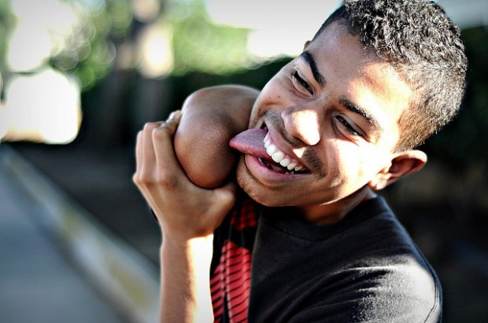
- Make a list of things that you have done and that you are proud of. eg. “I have touched my elbow with my tongue”. You can use an online dictionary www.diki.pl or the book dictionary from the shelf.
- _______________________________
- _______________________________
- ________________________________
- __________________________________
- _____________________________________
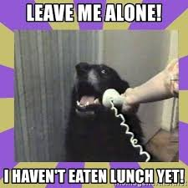
- Make a list of things that you haven’t done yet. (But you want to in the future!)
- __________________________________
- ____________________________________
- _____________________________________
- _____________________________________
- _____________________________________

Complete the following exercises:

Infinitive | Past Simple | Past Participle
ride
 | grew
 |  | written
 | was / were
drive
 |  | spoken
 |  | done
 | had
see
 | took

Choose the correct item.
1 Have you ever / never / just eaten fried worms?
2 We have just / ago / yet met Kate.
3 Mum has yet / ever / just met my English teacher.
4 My friends haven’t finished lunch just / yet / ago.
5 Sue’s little sister has yet / ago / just started school.
6 The cleaner hasn’t tidied the bathroom just / ever / yet.

Decide if the sentences are correct () or not ().
1 Sorry, I’ve forgotten your phone number.
2 I’ve forgotten Joe’s birthday last Monday.
3 My English teacher has changed her job.
4 Diana has written an email to me two weeks ago.
5 Tim’s seen a great film last night.
6 She’s been here since Sunday.

Complete the sentences with the present perfect form of the verbs in brackets.
1 _______ you _______ the new Twilight film? (see)
2 Hector _________ his injection. (have/just)
3 I __________ the dog yet. (not/brush)
4 My father ______ jeans. (never/wear)
5 Kate and Sarah ________ their clothes for the school trip yet. ( not/choose)
6 ______ your brother _________ Chinese food? (ever/eat)
7 They ______________ to Japan. (never/be)
8 Mum isn’t ready. She _________ her things yet. (not/pack)
Match the sentences to make short dialogues.
1 Have you read Tom’s new article? _____
2 She has won a holiday to Spain. _____
3 Is he ready for the trip to Greece? _____
4 Are your friends in the USA now? _____
5 Have you ever been to Paris? _____

a) Oh, what a great prize!
b) Yes, they’ve just gone there.
c) Yes, I’ve been there three times.
d) No, not yet. I haven’t had time.
e) Yes, he has already got his passport.

Choose: been or gone.
1 Where’s Mum? She’s ______ to the dentist’s.
2 Dad’s _____ shopping: the fridge is full.
3 Tom’s _____ to live in Spain.
4 I haven’t _____ to the library for weeks.
5 Have you ever _____ to Italy?
6 Joe’s ______ swimming. He’ll be back at 5.00.

